Elentra Onboarding Guidelines for Full Launch CBD Programs

OVERVIEW
Elentra is an online assessment platform that is being developed at the University of Toronto to support Competence By Design (CBD). Elentra is a consortium based application that benefits from the development work of all of the Faculties of Medicine in the consortium. Our team is open to suggestions for developmental changes to Elentra. However, all suggested changes need to be reviewed by the Elentra Working Group, the Elentra Steering Committee and/or Elentra Consortium before a decision can be reached.

Programs slated for full CBD launch will do so using Elentra. In order to prepare for launch, programs must follow the below implementation guidelines and complete the activities indicated in the checklist by their assigned due date, as communicated to you by the Post MD CBME Systems and Education team.

REQUIREMENTS FOR ONBOARDING TO ELENTRA – ACTIVITY INSTRUCTIONS & CHECKLIST
The following are required to determine your Program’s readiness to full launch in Elentra. Please indicate whether you have these items ready under the “Response” column, and make any “Notes”, as necessary.

# | Requirement | Response | Notes
 | Working versions (at a minimum) of your Royal College EPA documents
 | Curriculum and Assessment Map and/or EPA Plan – Helps programs structure the curricular and assessment components of implementation. This includes the implementation plans for Entrustable Professional Activities (EPAs), mapping each to its respective PGY year, site, rotation, and assessment tool, as well as indicating the target number of successful entrustments per EPA.
 | Training Experience (TE) Plan – Details the implementation plans for TEs in your program, mapping each to its respective PGY year, site, rotation, and educational context
 | EPA Assessment Tools – Working with the CBME Education Group, programs will develop their EPA Assessment Tools. The EPA Plan and the EPA Assessment Tool Template is used to structure the EPA assessment tools themselves (e.g. developing contextual variables (demographic data) and assessment criteria (milestones)).
 | Variance Report – In order to better align themselves with the CBD model, programs may opt to make changes to their on or off-service rotations (e.g. structure their rotations so that all residents are on-service during the Transition to Discipline phase so the home specialty can sign off that they have the appropriate entry-to-discipline skills). The variance report is where programs provide an overview of net changes (i.e. increases AND decreases) to ON and OFF service rotations that are different from the ‘usual’ patterns over the past 2-3 years. This is collated centrally for the purposes of minimizing negative service impacts across programs.
 | ITARs & Rotation Plans – Full launch CBD programs will develop the new ITARs and Rotation Plans for the launch cohort of their program. ITARs and Rotation Plans (as with ITERs and Goals & Objectives of a rotation, will continue to be populated and filled out in POWER).
Faculty and Learner List – Each program is required to provide a complete faculty list for upload into Elentra. Learner imports will be developed centrally by PGME using POWER. The following information is required on the faculty list:
  - First Name
  - Last Name
  - Email Address
  - UTORid
A quality assurance (QA) process is required before any learners or faculty can be added to Elentra. The length of each program’s faculty and learner list will determine how long that QA process will take.

IMPLEMENTATION PROCESS
- Launch Date – Your CBD launch date is set nationally. The Post MD CBME Systems and Education Team will work with you closely to ensure your program is set for launch.

- Form Building – The CBME Education and Systems team will begin to build your EPA assessment tools in Elentra. Once they are completed, the Program Director will be e-mailed preview links of each tool for review and sign-off. Programs will have the opportunity to request any final changes to their tools at this point, as tools cannot be modified once they are launched.

- Training – The Elentra Team will provide a general training session for program administrators and are available for live demonstrations during faculty and resident development sessions. Please notify the team at least 2 weeks in advance of any demonstration request.

- Going Live – On your CBD launch date, an email will be sent out to all users notifying them how to access Elentra, as well as who to contact for help if needed.

APPENDIX – CBD Implementation Process (Gantt Chart) for 2019-20
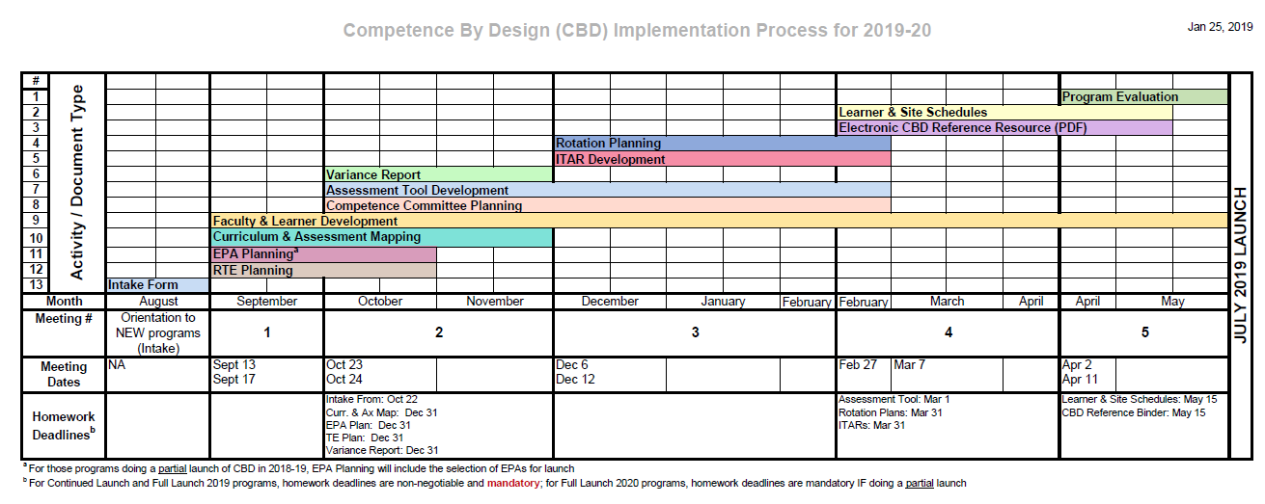

See Appendix for sample CBD Implementation Process (Gantt Chart) that takes place the year prior to full launch
Users may still complete assessments without an UTORid; however, they will not be able to log into Elentra without one.

